Presentation of the General Project Context

Introduction
In this chapter, we present the host company, offering a detailed overview of its history, mission, and activities. Understanding the role and importance of ECI is essential to fully grasp this internship experience. By examining the organization's past, its objectives, and its core principles, we can better understand the environment in which this internship takes place and identify the unique opportunities it presents.

Presentation of the Host Company

General Company Overview
ECI (Electrical Components International) was founded in 1953 as Burcliff Industries. It has become one of the world's leading suppliers of electrical distribution systems, control box assemblies, and critical technical components. The company currently employs 17,000 people across 30 manufacturing sites worldwide, serving over 450 clients.
ECI designs, manufactures, and assembles electrical distribution systems, control boxes, and other critical technical components that enable the deployment of advanced technologies across various industrial sectors. Its slogan reflects this mission: "Powering Smart, Connected, and Electrified Solutions."
Figure 1 shows the global presence of the ECI group.
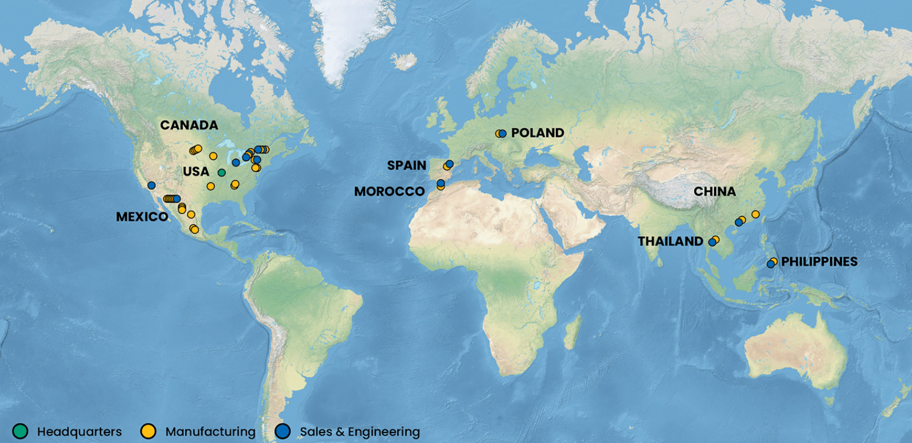
Figure 1: Global locations of ECI

Markets, Customers, and Suppliers
ECI serves over 450 market-leading customers across a wide range of industries, positioning itself as a supplier capable of managing highly complex requirements in terms of products, demand, manufacturing, and delivery. Its main markets include:
Home Appliance: Global leader in wire harnesses and control box assemblies for major home appliance OEMs worldwide since 1953.
Automotive Advanced Safety: Over 27 years of experience in manufacturing wire harnesses for ADAS systems, including cameras, sensors, and exterior mirrors.
Commercial Electric Vehicles: Through its ProEV™ brand, ECI leads the electrification of school buses, delivery trucks, and urban transport vehicles.
Aerospace: Supply of wiring harnesses and kits for commercial, business, and military aircraft platforms.
Medical Devices: Electrical distribution systems for diagnostic equipment, including MRI machines, X-ray imaging, and surgical applications.
Smart Industrial & Access Equipment: Wiring harnesses for forklifts, cranes, scissor lifts, and automated industrial machinery.
Figures 2 and 3 show the main suppliers and customers of ECI Tangier, respectively.
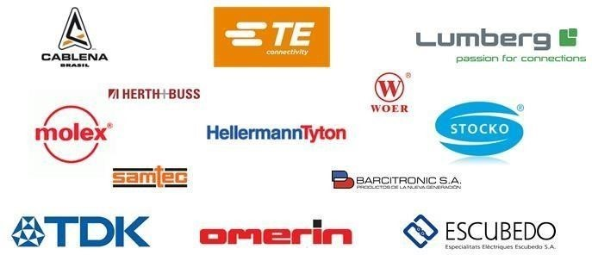
Figure 2: ECI suppliers
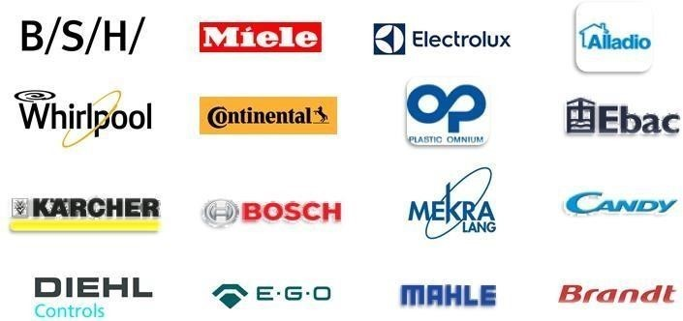
Figure 3: ECI customers

ECI subsidiaries
Figure 4 presents the subsidiaries of the ECI group.
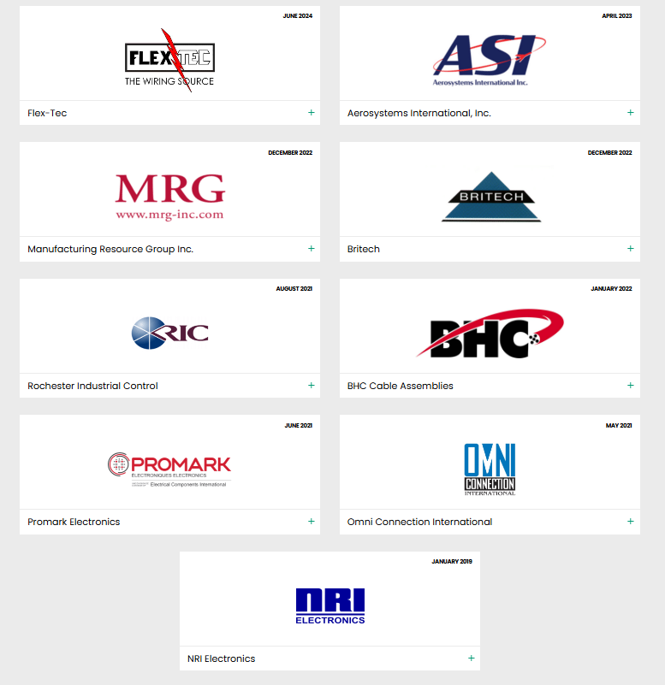
Figure 4: ECI subsidiaries

Vision and Values
ECI's vision is to power the next generation of smart, connected, and electrified technologies. The company positions itself not merely as a component supplier, but as a long-term design and engineering partner, supporting its customers from concept development to large-scale production. Its four core values are:
Operational Excellence: A culture of "zero defects," Lean Manufacturing, and continuous improvement at all production levels.
Customer Commitment: On-time delivery and first-class service represent ECI's absolute operational priority, supported by advanced demand analytics.
Ethical Excellence: Integrity, collective responsibility, and commitment to promises at all levels of the organization.
Leadership en Innovation et Technologie : Investissement continu dans 3l'électrification, l'automatisation et la fabrication numérique (Digital Manufacturing).

ECI Morocco
The Tangier plant, established in 2014 as the first investor in Tanger Automotive City (TAC), reached a major milestone in 2024 with the inauguration of its production site extension. This expansion increased annual production capacity to 40 million units and consolidated a workforce of 1,400 employees. This development underscores ECI's strategic commitment to Morocco and its active contribution to the industrial development of the Tangier-Tétouan-Al Hoceima region.
Figure 5 shows the ECI Morocco site.
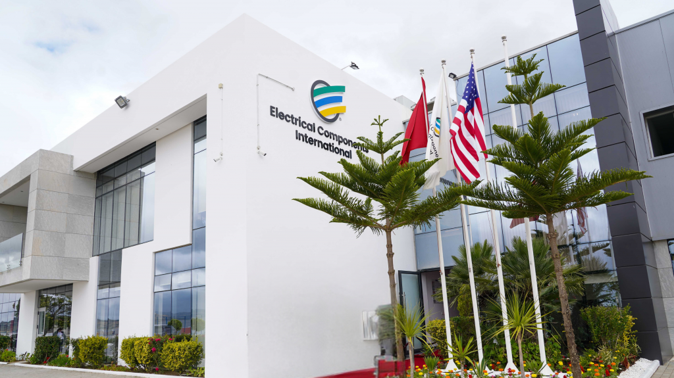
Figure 5: ECI Morocco

Company Profile Sheet
Table 1 presents the company profile sheet for ECI Tangier.
Company Name | Electrical Components International Morocco (ECI Morocco)
Legal Form | Public Limited Company (PLC)
Type d’activité | Fabrication et assemblage de faisceaux de câbles (wire harnesses), systèmes de distribution électrique et composants électroniques techniques
Year of Establishment | 2014
Capital | 166,099,000.00 MAD
Workforce (Morocco) | Approximately 1,400 direct employees
Production Capacity | 40 million units per year (following the 2024 expansion)
Address | Zone Franche Tanger Automotive City (TAC), Tangier, Morocco
Telephone | +212 531 063 615
Website | www.ecintl.com
Parent Company | Electrical Components International, Inc. — Headquarters: Southfield, Michigan, USA
Certifications | ISO 9001:2015 (Quality Management) — IATF 16949 (Automotive) — ISO 14001:2015 (Environment)
Markets Served | Automobile, Électroménager, Véhicules Électriques Commerciaux, Aéronautique, Équipements Industriels
Industrial Zone | Export Free Zone — Tanger Med Industrial Platform
Table 1: Company Profile Sheet

Production Zones
The production flow is organized into four main zones:
- Warehouse and Feeding
This is the starting point located on the left side of the layout. The warehouse stores raw materials that feed the various work areas. This is where my Pick-to-Light project intervenes to optimize component preparation before they are sent to production.
- Cutting and Preparation Zone
Once materials leave the warehouse, they go through the Cutting Zone (APU Cutting). The operations performed include:
- Cutting to length.
- Wire stripping and crimping.
- Connector insertion (Semi-IDC) and twisting.
- Zone d’Assemblage
This is the central and largest area of the plant. It consists of individual assembly stations where the final tasks are performed:
- Taping (harness protection).
- Packaging and continuity or quality testing.
- Inspection and Shipping
Enfin, les produits passent par une zone de contrôle final (sans valeur ajoutée technique mais cruciale pour la qualité) avant d'atteindre la Zone d’expédition pour être envoyés aux clients.
Figure 6 shows the general production flow of ECI Tangier, from the raw materials warehouse to shipping.
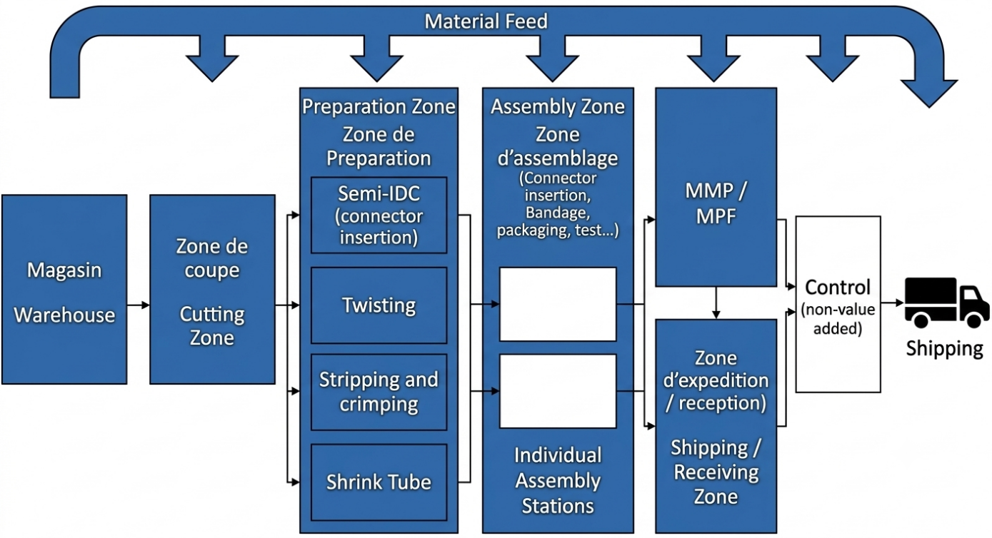
Figure 6 General plant layout.

Figure 7 presents the synoptic diagram of the production zones of ECI Tangier.
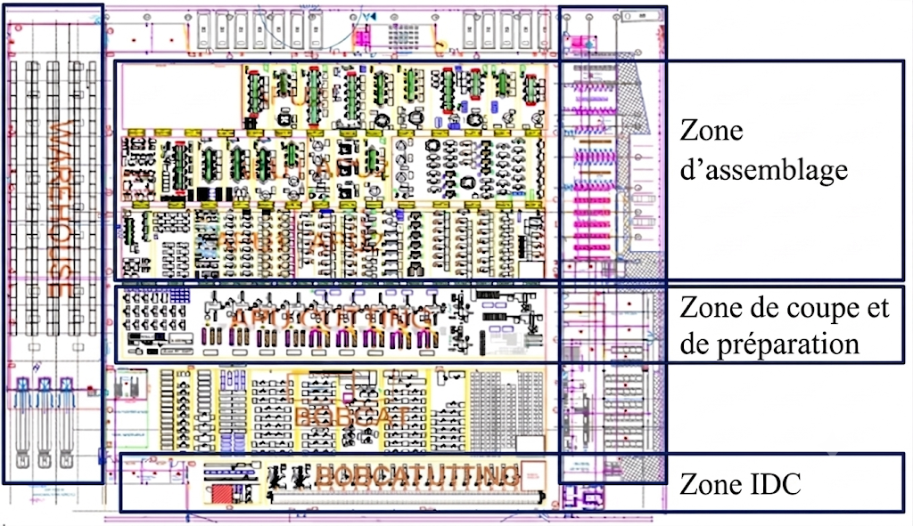
Figure 7: Production flow diagram

Product Range Manufactured by ECI Tangier
Figure 8 shows the range of products manufactured by ECI Tangier, divided between the automotive and home appliance sectors.
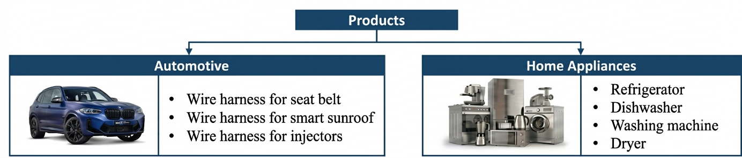

Figure 2: Segmentation du portefeuille produits d’ECI Maroc

Organigramme d’ECI
Figure 9 presents the organizational chart of the ECI Tangier site, with a focus on the Engineering Department within which this final year project takes place.
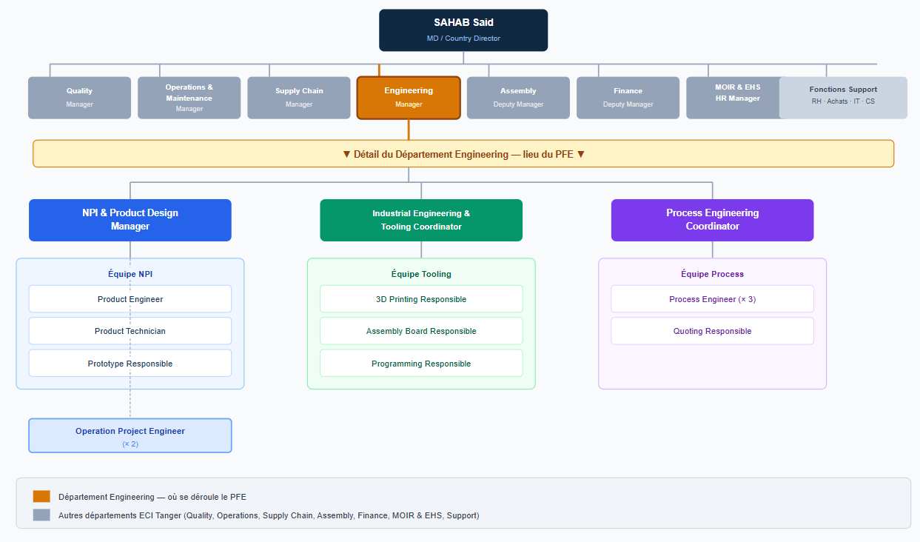
Figure 3:Départements d’ECI
ECI Tangier is organized into complementary functional departments, each contributing to the overall operational efficiency of the plant.
The general structure is presented in Table 2.
Department | Main Responsibilities
General Management | Overall management of the plant, strategy and performance supervision.
Production | Manufacture of cable harnesses, management of assembly lines, and achievement of performance objectives.
Quality Assurance | Product inspection, compliance with customer standards and defect prevention.
Process Engineering | Optimization of processes and digitalization initiatives—Internship host department.
Supply Chain & Warehouse | Raw material supply, inventory management and logistics.
Human Resources | Recruitment, training, and labor relations.
Finance & Administration | Budgeting, reporting, and administrative operations.
NPI Product | New product study
Tableau 1: ECI Departments
- Project Context

Pedagogical Context
This project is part of the end-of-studies internship as a master’s student in order to obtain the Master’s degree in mechatronics. at the Faculty of Sciences of Tetouan – FST the main objective of this internship is to integrate into a professional environment and to get used to it. work in real situations in order to develop the strengths acquired during the training. Educational

General Context
The Smart Storage Management System (SSMS) is a Pick-to-Light / Put-to-Light warehouse management solution designed for a partner industrial facility. The system uses WS2813 addressable RGB LEDs installed on storage bins to guide operators during picking and stocking operations, reducing human error and improving retrieval speed. The system is controlled by an ESP32-WROOM-32D microcontroller running MicroPython firmware, communicating via MQTT over a local LAN with a Windows desktop application built in Python/Tkinter.

Need Analysis — Bête à Cornes Diagram

The Bête à Cornes (Horn Beast) diagram defines the purpose of the product by answering three fundamental questions: Who does the product act on? What does it act on? What is its purpose?

Process Engineering Department
The Process Engineering Department at ECI Tangier is responsible for analyzing, designing, and continuously improving the plant's manufacturing and logistics processes. Operating at the intersection of industrial engineering and digital technologies, it constitutes the main driver of the company's Industry 4.0 strategy.
It is within this department that this final year project takes place.

  - Warehouse Overview
ECI Tangier's raw materials warehouse manages the reception, storage, and supply of all components required for cable harness manufacturing: cables of various gauges, connectors, terminals, and protective sheaths.
Physical and logical organization: The warehouse is structured around 7 storage racks, subdivided into individual locations identified by a position code.
- Current capacity: 252 active storage positions spread across 7 racks.
- State management: Each location is associated with a specific reference and has a binary status: FULL (busy) or EMPTY (available).
Operational flows: Management is based on two types of movements performed by operators:
- PUT (Stocking): Placing raw materials in the designated location.
- PICK (Picking): Removing components to supply production lines.
The accuracy and speed of these operations are critical: any identification error or picking delay directly impacts production line continuity. It is in this context that optimization through the Pick-to-Light system is undertaken.
Figure 10 illustrates the ECI Tangier raw materials warehouse, where components such as wire spools, connectors, and terminals used in electrical harness manufacturing are stored.
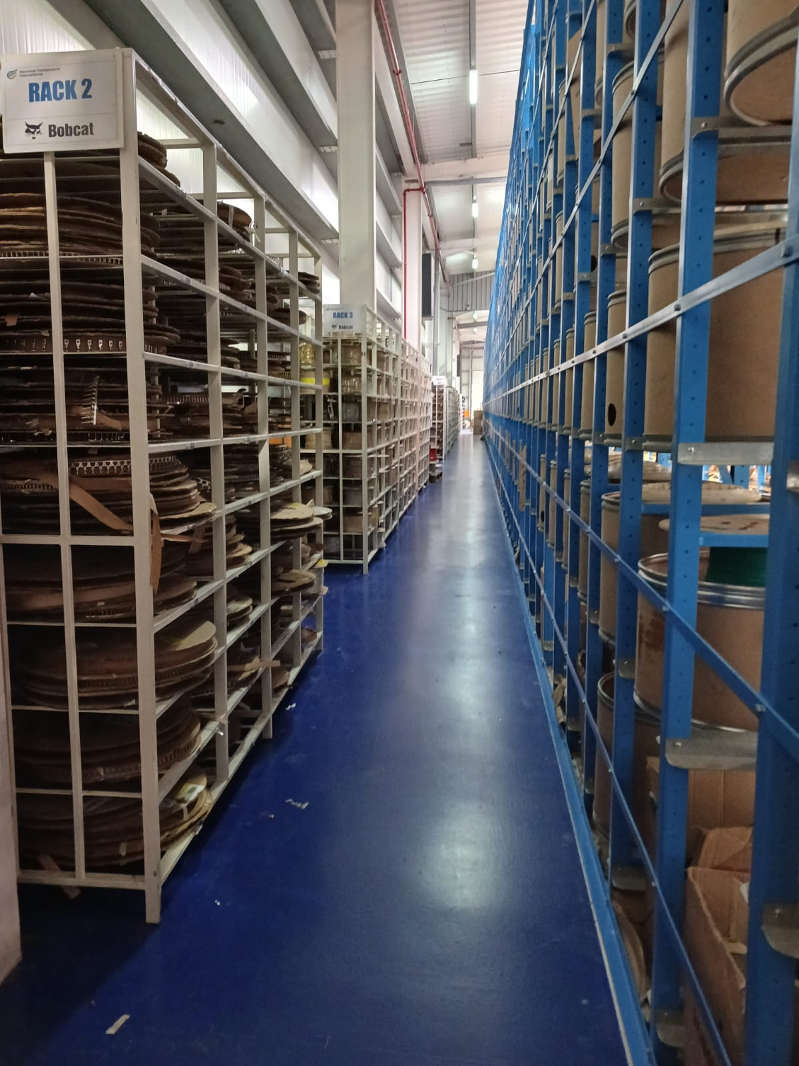
Figure 10: Raw materials warehouse

  - Problem Analysis and Current Process Limitations
    - Problem Analysis Using the 5W2H framework
To rigorously frame the operational problem identified within the raw materials warehouse, the 5W2H method was applied. This structured analysis tool, whose acronym stands for Who, What, Where, When, How, Why, is widely used in industrial engineering and continuous improvement approaches to break down a problem into its fundamental dimensions, ensuring that no critical aspect is overlooked before defining a solution. Unlike a simple description of symptoms, 5W2H forces the analyst to examine the problem from multiple angles simultaneously, establishing a complete and objective diagnosis that serves as the foundation for any improvement initiative.
Applied to the warehouse management situation at ECI Tangier, the analysis yields the structured breakdown shown in Table 3.
Dimension | Question | Analysis
Who? | Who is affected by the problem? | Warehouse operators in charge of PUT and PICK operations, as well as production supervisors who depend on the exact availability of stocks
What? | What is the problem? | The absence of a real-time digitalized guidance system for raw material storage and sampling operations, leading to manual errors and traceability gaps
Where? | Where does the problem occur? | Raw materials store—storage racks, ECI Tangier production site
When? | When does the problem occur? | At each PUT or PICK operation triggered by a production request, occurring daily throughout the work shifts
How? | How does the problem manifest? | Operators rely on printed sheets or static Excel files to locate the materials, without any confirmation mechanism to validate the accuracy of the operation performed
Why? | Why does the problem exist? | No digitalized store management system has been deployed; the existing process was designed for low volumes and has not evolved to meet current production requirements
Table 3: 5W2H framework
This structured analysis reveals that the root cause of the problem is not operator negligence, but rather a systemic lack in the warehouse management infrastructure. The absence of real-time digital guidance creates conditions where errors are not merely possible but structurally inevitable, regardless of operator experience or attention, with operators losing considerable time in manual searching for the correct location. The 5W2H thus confirms that the solution must act at the system level, not the individual level, by introducing a technology-driven guidance and validation mechanism capable of eliminating all ambiguity at each step of the material handling process.
    - Current Process Limitations
Before the implementation of the Pick/Put-to-Light system, raw material management was based on a largely manual process. Operators identified storage locations by looking at printed sheets or static Excel files, without any real-time digital guidance. The typical operational flow was as follows: upon receipt of a production request, the operator consulted the list of references to identify the assigned rack and position, physically moved to the location, carried out the PUT (placing in stock) or PICK (picking) operation., then manually updated the stock records. Although functional for low volumes, this workflow has generated increasing operational inefficiencies as production rates have increased. The analysis of the existing process revealed a set of recurring limitations justifying the need for a digitized and guided system, as presented in Figure 11.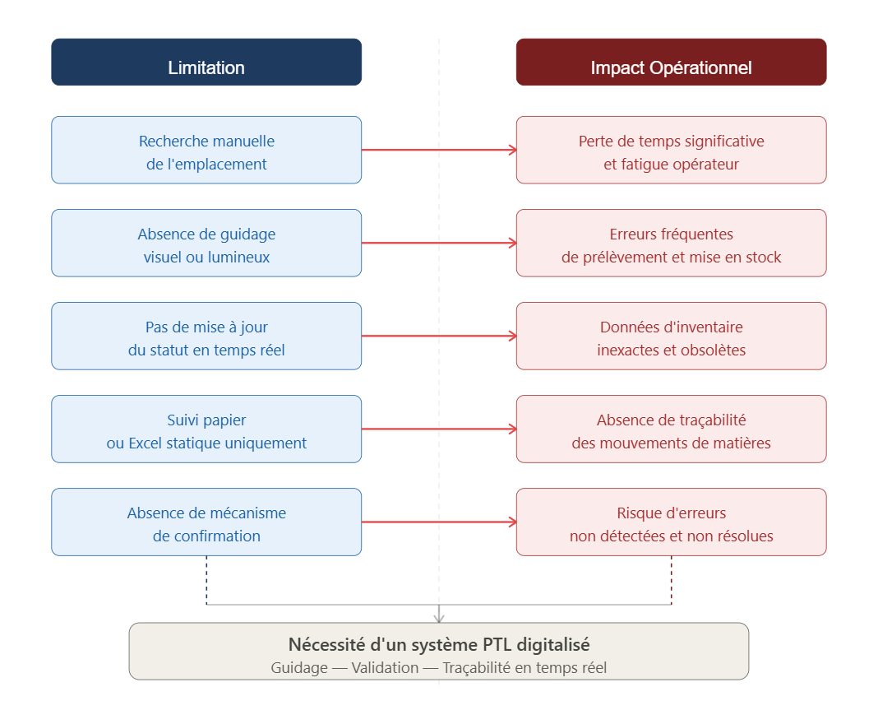
Figure 11: Limitation diagram and operational impact
The accumulation of these limitations led to measurable losses in operational efficiency, increased the risk of traceability gaps, and made real-time supervision complex. The absence of a structured and technological process was identified as a major gap in the plant's Industry 4.0 digitalization roadmap, constituting the direct motivation for this project.
  - Project Objectives and Scope
The main objective of this project is to design and implement a Pick-to-Light (PTL) system within the ECI Tangier raw materials warehouse.
This system aims to digitize material handling operations, eliminate manual search errors, and provide real-time visibility into stock status. This project represents a concrete contribution to ECI's Industry 4.0 transformation.
The specific project objectives are detailed below:
- LED Guidance: Guide operators to the exact storage position via NeoPixel LEDs controlled by ESP32 microcontrollers.
- Double Confirmation: Implement a two-step barcode validation mechanism (position scan + reference scan) to eliminate errors.
- Real-Time HMI: Develop a Human-Machine Interface (HMI) for live monitoring of warehouse status and stock levels.
- Full Traceability: Ensure complete traceability of all PUT and PICK operations with data export (Excel).
- Standalone Deployment: Deploy a standalone industrial-grade application (.exe) usable without third-party development tools.
- Project Management
  - Specifications
These specifications, presented in Table 4, define the formal framework of the project, specifying the expected objectives, the constraints to be respected, the scope of intervention as well as the deliverables and success criteria that will validate the achievement of the targeted results.
Table 4: Project Specifications
IDENTIFICATION
Project | Design and Implementation of a Smart Storage Management System based on Pick/Put-To-Light Technology - ECI Tangier Raw Materials Store
Project Owner | Mohamed DAGMOUMI ESSAFI — Process Engineer intern, Process Engineering Department
Company Supervisor | Mr. Saad Bouamar — Process Engineer, ECI Tangier
Period | February 2026 — July 5, 2026 (5 months)
MAIN OBJECTIVE
Digitize the management of ECI Tangier’s raw materials warehouse by deploying a low-cost Pick-to-Light system based on IoT technologies, in order to guide operators in real time, eliminate manual errors and ensure complete traceability of PUT/PICK operations.
SPECIFIC OBJECTIVES
1 | Implement a light guide using NeoPixel LEDs controlled via an ESP32 microcontroller
2 | Develop a double validation mechanism by barcode scanning (position + reference)
3 | Design a real-time HMI in Python/CustomTkinter for store supervision
4 | Ensure the complete traceability of movements with Excel export
5 | Deploy a standalone application (.exe) without technical dependencies
6 | Minimize total cost by using low-cost components and open source software
CONSTRAINTS
Technical | Guided only by LEDs and no sound sensors or screens per location
Technical | Wireless communication via WiFi + MQTT protocol (no dedicated cabling)
Financial | Minimal budget, low-cost components and open-source tools only
Temporal | Delivery of the functional system before 05 July 2026
Organizational | Immediate handling by operators without prior technical training
SCOPE
Included | 7 racks, 252 positions actives, opérations PUT et PICK et IHM + ESP32 + MQTT + Excel
Excluded | Other areas of the factory, multi-site management
DELIVERABLES
PTL System | Hardware (ESP32 + LEDs) operational on the 7 warehouse racks
Python HMI | Standalone application with real-time monitoring, KPIs and Excel file export
Internship Report | Complete document structured by chapters
SUCCESS CRITERIA
Guidance | The LED at the correct location lights up in less than 2 seconds after entering
Validation | No operation confirmed without double scan (position + reference)
Traceability | All operations are recorded and exportable in real time
Deployment | Functional application in .exe without installing a technical environment
Table 4: Project Specifications
  - Planning: Gantt Chart
Figure 12 presents the Gantt chart for planning our project, spanning 19 weeks from February to June 2026.
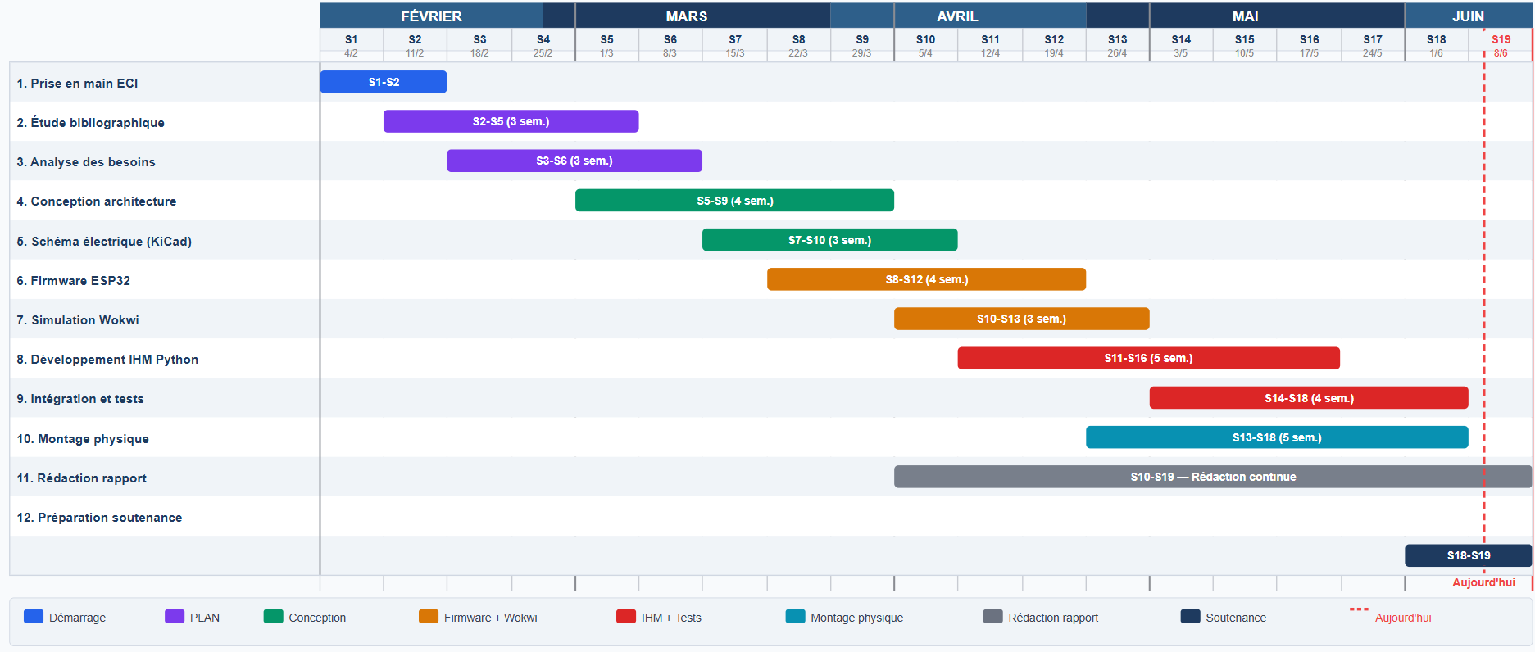
Figure 12: Gantt Chart
  - Improvement Approach — V-Cycle Methodology
The V-Model (V-Cycle)
The V-Model is a widely used system development life cycle model in engineering, particularly for projects combining hardware and software. Emerging as an evolution of the waterfall model in the 1980s–1990s, especially in the aerospace, automotive, and defense sectors, it was designed to overcome the limitations of strictly linear approaches by integrating test planning from the earliest design phases rather than at the end of the project. [1]
Its name comes from the graphical representation of the process: a descending branch dedicated to specification and design, and an ascending branch dedicated to verification and validation. Each design stage is explicitly linked to its corresponding test activity.
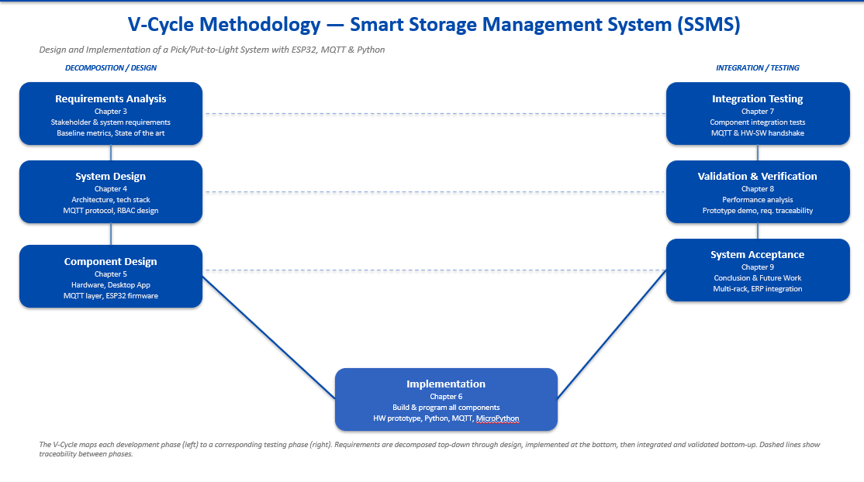
Figure 4: V-Cycle Methodology — Smart Storage Management System (SSMS)

In the context of this project, the V-Model structures the work into six phases:
- Requirements Analysis — Gathering functional and non-functional requirements from stakeholders and establishing baseline indicators of the current system.
- System Design — Defining the overall architecture, decomposing into subsystems, and selecting the technology stack and communication protocols.
- Detailed Design — Fine specification of each subsystem: hardware, desktop application, MQTT layer, and ESP32 firmware.
- Implementation — Development and programming of each component: hardware prototype, Python application, broker configuration, and MicroPython firmware.
- Integration Testing — Verifying the joint operation of components: MQTT communication, hardware–software linkage, and end-to-end processes.
- Validation & Verification — Confirming that the system meets all initial requirements: error rate reduction, recovery time, scalability, and reliability.
This approach is not presented as an isolated section of the report but as a transversal logic visible throughout the chapters: each design phase (Chapters 1, 3 to 7) corresponds to a testing phase (Chapter 8), ensuring that every requirement defined upstream is explicitly verified downstream.

Cette démarche cyclique garantit que chaque décision prise au cours du projet s’appuie sur une analyse préalable, que les résultats sont systématiquement évalués par rapport aux objectifs fixés, et que les écarts identifiés donnent lieu à des actions correctives concrètes. Elle constitue ainsi le cadre méthodologique qui sous-tend l’ensemble de la démarche d’ingénierie développée dans ce rapport.
Conclusion
This first chapter has laid the contextual foundations of the project. Through the presentation of ECI Tangier and its industrial environment, we have identified the limitations of the manual warehouse management process and precisely defined the objectives of the system to be designed. The adopted methodological framework, structured around the V-Model approach, ensures a rigorous and coherent approach throughout this work. In this approach, this chapter represents the beginning of the PLAN phase: problem analysis, needs definition, and project planning. The following chapter focuses on establishing the theoretical and technological foundations upon which the developed solution is based.
.

